NeuroAssist AI

Software Requirements Document (SRD)

Phase 1 – MVP Release

Version 1.0

Prepared By:

Project: NeuroAssist AI Platform

Organization: SipraHub

Date:

Table of Content

S.no | Topic | Page no.
1 | Introduction | 3
1.1 | Purpose of the Document
1.2 | System Overview
1.3 | System Architecture
1.4 | Scope of MVP
1.5 | Assumptions
1.6 | Definitions & Acronyms
1.7 | Constraints
2 | User Flows | 7
2.1 | Patient Workflow
2.2 | Doctor Workflow
3 | Functional Requirements | 9
3.1 | Patient Registration
3.2 | Pre-Vist Questionnaire
3.3 | Doctor Pre-Consultation Summary
3.4 | Doctor Audio Upload
4 | Non-Functional Requirements | 15
5 | Data Requirements | 16
6 | Exclusions for Phase 1 | 16
7 | Acceptance criteria for MVP Success | 17

NeuroAssist AI – Software Requirements Document (SRD)

PHASE 1: MVP RELEASE ONLY
Version: 1.0

1. Introduction

1.1 Purpose of the Document
This SRD defines all functional, non-functional, data, and system requirements for Phase 1 (MVP) of NeuroAssist AI — the minimum version required to pilot the system with neurologists and patients. The purpose of this Software Requirements Document (SRD) is to define the full set of functional, non-functional, system, and data requirements for Phase 1 (MVP) of the NeuroAssist AI platform.
This SRD will be used by:
- Product team (feature alignment)
- Engineering team (implementation)
- QA team (test case creation)
- Clinicians and stakeholders (validation of scope)
This SRD covers only the minimum set of features required to:
- Pilot the system in selected neurology clinics
- Validate core workflows
- Demonstrate time savings and quality improvements
- Build foundation for Phase 2 and Phase 3 enhancements.

1.2 System Overview
NeuroAssist AI is a clinical workflow automation platform that reduces consultation time and improves care quality for neurologists by capturing structured diagnostic information before the visit and automating documentation during the consultation.
The MVP consists of four primary subsystems:
- Patient Mobile App – registration, questionnaire, appointments, reminders
- Front Desk Portal – check-in, billing, queue management
- Doctor Console – pre-consult summary, documentation, diagnosis, prescription
- Backend + Basic AI Engine – rules logic, data storage, medication knowledge base
The AI layer in Phase 1 is limited to simple pattern detection and rule-based suggestions.

1.3 System Architecture

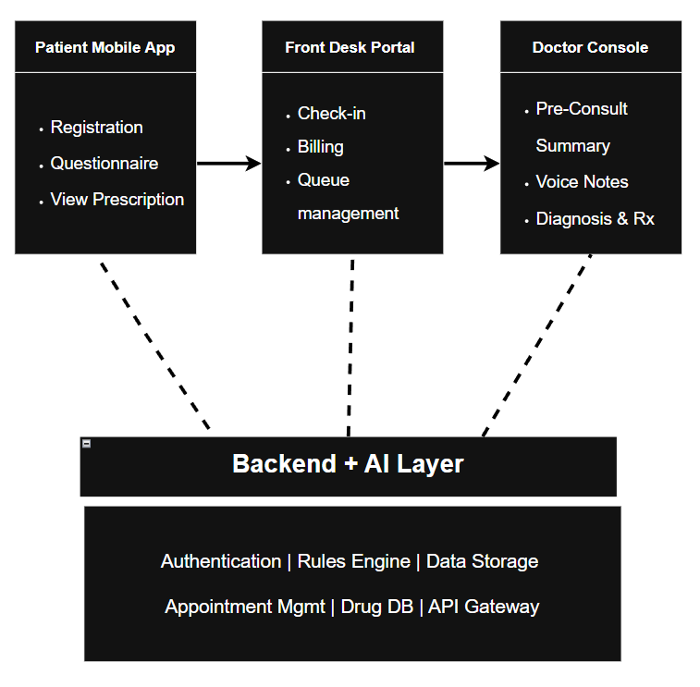

1.4 Scope of MVP (Phase 1)

In-Scope Features
- Patient onboarding & authentication
- Doctor console with:
  - Voice-to-text documentation
  - Auto-populated summary
  - Basic AI risk flags

Out of Scope (Future Releases)
- Lab integrations
- Side-effect monitoring
- Symptom diaries
- Video consultations
- Emergency teleconsultation
- Predictive analytics
- Insurance workflows
- Second opinion modules
- Pharmacy integrations
These features are part of Phase 2 and Phase 3.

1.5 Assumptions
- Patients have access to a smartphone with the internet.
- Clinics have basic infrastructure (Wi-Fi or 4G).
- Doctors are comfortable with digital prescription workflows.
- Front desk staff can operate a web portal.

1.6 Definitions & Acronyms

Term | Definition
MVP | Minimum Viable Product
AI | Artificial Intelligence (rule-based in Phase 1)
CDSS | Clinical Decision Support System
ICD-10 | International Classification of Diseases (codes for diagnosis)
OCR | Optical Character Recognition
NFR | Non-Functional Requirement

1.7 Constraints
- No external lab/pharmacy integration allowed in Phase 1.
- All AI must remain basic and rule-based.
- Offline capability must be limited to reading cached data and filling forms.
- The system must be GDPR/HIPAA-inspired, but real compliance depends on future versions.

2. User Workflows

2.1: Patient Workflow
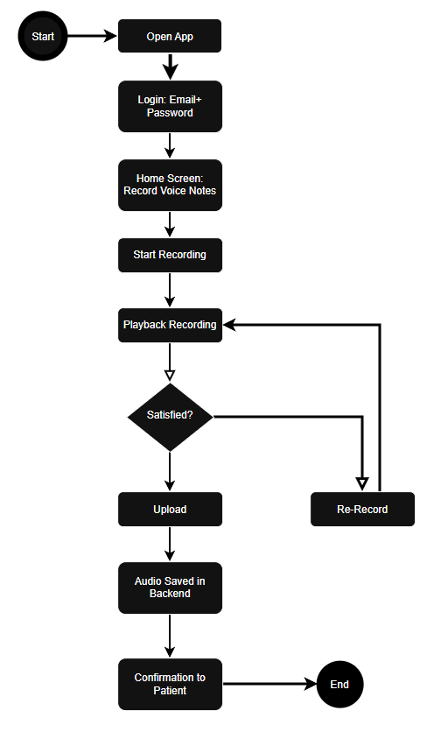

2.2: Doctor Workflow - AI Transcription & SOAP Note Generation

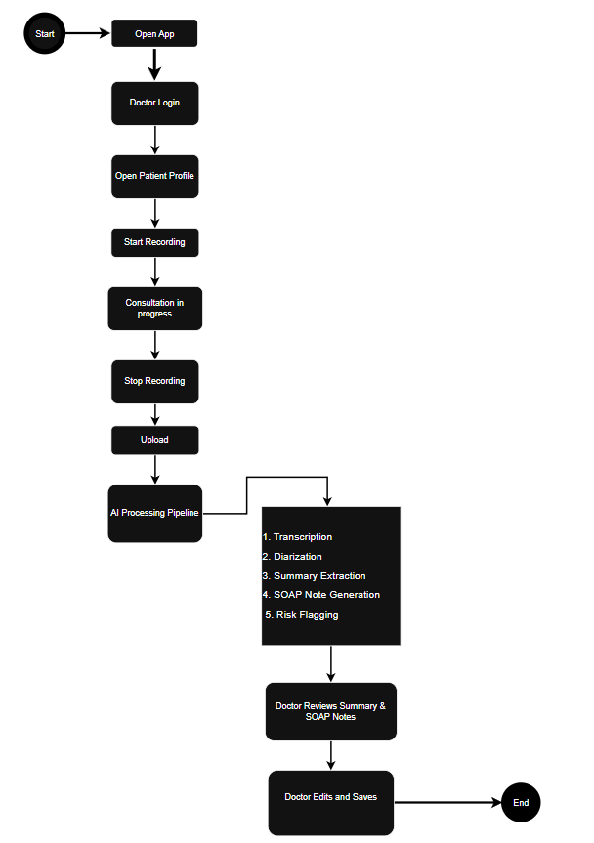

3. Functional Requirements (FR)
Each requirement includes:
- Description
- Details
- Acceptance Criteria

FR-1: Patient Registration & Authentication

Description
Allows users to log in to the system using an email-based login flow.

Details
- User logs in using email+password.
- Profile fields: name, age, gender, phone, email, location
- Optional emergency contact
- Unique Patient ID assigned

Acceptance Criteria
- Registration must complete within 2 minutes
- Successful email login ≥ 95%
- User profile stored securely

FR-2: Pre-Visit Questionnaire (Core MVP Feature)

Description
Captures detailed health information using conditional logic pathways.

Details
- The user sees a “Record Voice Note” button.
- Users can record up to 60 seconds of audio.
- Basic controls:
- Start Recording
- Stop Recording
- Playback
- Delete / Re-record
- Voice note is uploaded to the backend and attached to the user profile.
- Optional: User can add a short text label (e.g., “Headache description”).

Acceptance Criteria
- Recording starts within 1 second
- Maximum recording length: 60 seconds
- Audio upload success ≥ 98%
- User can re-record multiple times

FR-3: Doctor Pre-Consultation Summary

Description
Because MVP only includes a patient voice recording, the doctor view shows only the uploaded audio file.

Details
- Doctor Console display:
  - Patient Name
  - Timestamp of voice note
  - Playback controls for the voice file
- No AI analysis, no probable diagnosis, no risk flags.

Acceptance Criteria
- Doctor can play audio file without lag
- File loads in under 2 seconds
- Correct audio associated with correct patient

FR-4: Doctor Consultation Interface

Description
The doctor must be able to record the consultation using the app, and the system must automatically:
- Transcribe the full conversation
- Apply speaker diarization (Doctor vs. Patient)
- Generate a structured AI summary
- Produce a SOAP note (Subjective, Objective, Assessment, Plan)
- Highlight risk flags based on keywords, symptoms, or clinical patterns
This replaces the previous manual doctor notes.

Details
Doctor Console features:
Consultation Recording
- Start / Stop recording button
- Optional Pause / Resume
- Playback of recorded audio
- Audio stored securely in backend
- Maximum recording length: 15 minutes
AI Transcription & Diarization
- Converts audio to text
- Labels segments as Doctor or Patient
- Supports medical vocabulary
AI Summary Generation
- Extracts key symptoms
- Extracts clinical findings
- Highlights red flags
- Summarizes next steps discussed
SOAP Note Creation
- S: Patient symptoms captured in consultation
- O: Observable findings mentioned verbally
- A: AI-generated assessment (non-diagnostic)
- P: Plan including tests or steps discussed
- Doctor can edit all sections
Risk Flagging
- Identifies urgent symptoms
- Stroke / seizure indicators
- Medication contraindication mentions
- Flags displayed in red

Acceptance Criteria
- Recording begins within 1 second
- Transcription generated in ≤ 20 seconds
- Diarization accuracy ≥ 75%
- SOAP note generated in correct S-O-A-P format 100% of the time
- Doctor can edit AI-generated notes
- Risk flags appear clearly when detected
- Audio saved with timestamp, Patient ID & Doctor ID

FR-4: Doctor Audio Upload (External Recording Upload Feature)

Description
The doctor must be able to upload an existing consultation audio file.
The system should process it the same way as a live recording:
- Transcribe
- Diarize
- Summarize
- Generate SOAP note
- Apply risk flagging

Details
Doctor Console upload capabilities:
Audio File Upload
- Doctor-only feature
- Supports .mp3, .m4a, .wav
- Maximum file size: 50 MB
- Uploaded file stored securely
Processing Pipeline
Once uploaded:
- System stores the audio
- AI transcription begins
- Diarization applied (Doctor/Patient)
- AI summary created
- SOAP note generated
- Doctor notified when processing is complete

Acceptance Criteria
- Upload succeeds ≥ 98% of attempts
- Processing completes within ≤ 45 seconds
- Transcript, summary, SOAP note, and risk flags appear correctly
- Only doctors can access or upload files
- Uploaded file correctly associated with patient

4. Non-Functional Requirements (NFR)

NFR-1: Performance
- All screens load in < 2 seconds
- Doctor voice transcription latency < 300 ms

NFR-2: Reliability
- Auto-save on all forms
- Offline mode for questionnaire

NFR-3: Security
- End-to-end encryption
- Role-based access control (patient, doctor, admin)
- Session timeouts

NFR-4: Scalability
- Supports up to:
  - 10 clinics
  - 300 daily active users

NFR-5: Availability
- System uptime ≥ 98%

5. Data Requirements

Patient Data Includes:
- Profile information
- Questionnaire responses
- Uploaded documents
- Appointment history
- Prescriptions
- Medication reminders

Doctor Data Includes:
- Consultation notes
- Diagnoses
- Prescription metadata
- Queue data

System Data Includes:
- Audit log records
- Billing entries

6. Exclusions for Phase 1
These will be included in Phase 2 or Phase 3:
❌ Lab integration
❌ Second opinion module
❌ Emergency teleconsultation
❌ Prediction analytics
❌ Multi-clinic advanced analytics
❌ Video consultation
❌ Side-effect monitoring
❌ Symptom diary
❌ Insurance integrations

7. Acceptance Criteria for MVP Success
Phase 1 is considered successful when:
- 95% of patients can complete pre-visit questionnaire end-to-end
- Doctors complete consultations in ≤ 20 minutes on average
- Prescription generation takes ≤ 30 seconds
- System uptime ≥ 98%
- Queue and billing workflows work flawlessly

Metric | Target
Questionnaire completion | ≥ 95%
Avg. consultation time | ≤ 20 min
Prescription generation | ≤ 30 sec
System uptime | ≥ 98%
Queue workflow errors | 0 critical issues

